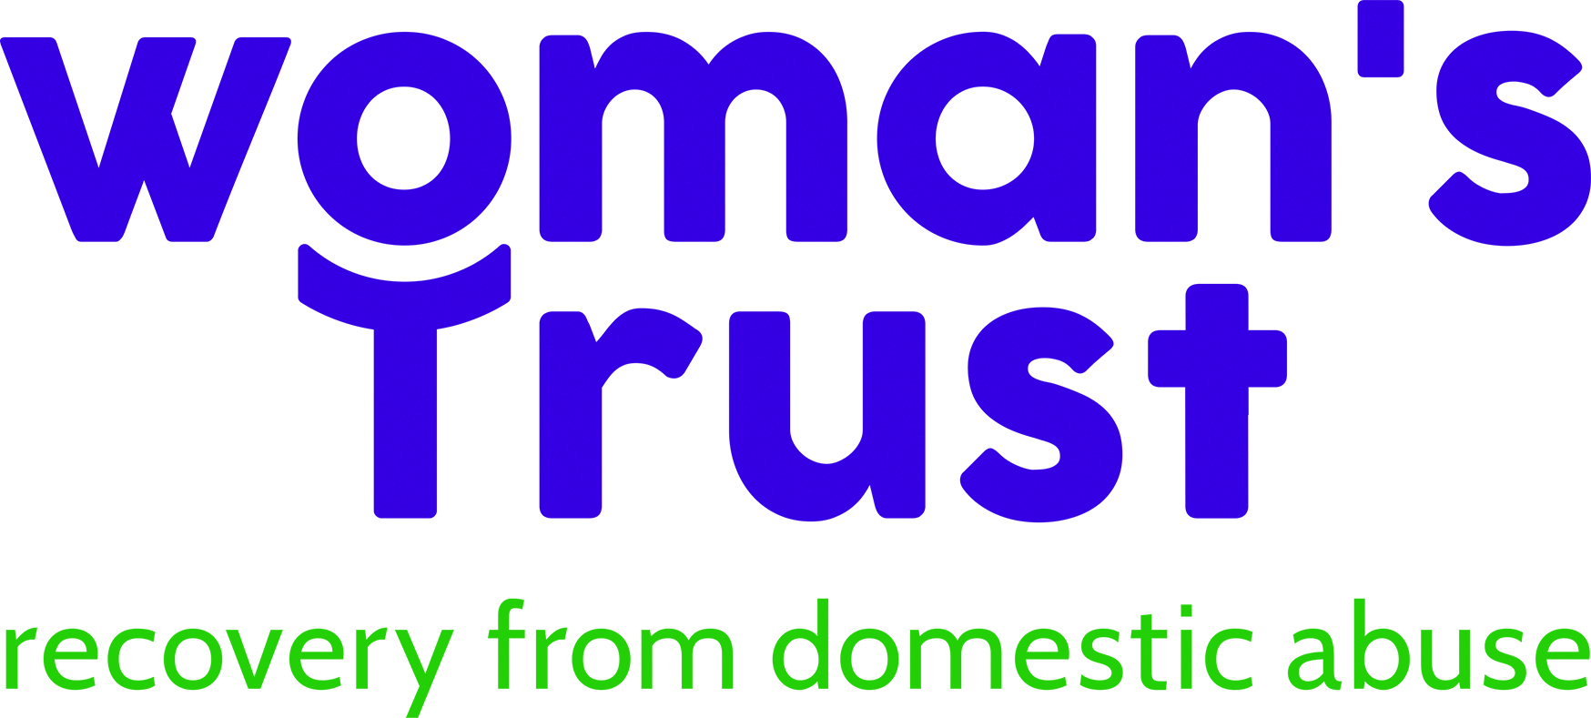
Press release
September 2023
Marilyn Monroe lookalike runs for Woman’s Trust to raise awareness of domestic abuse
Internationally renowned Marilyn Monroe impersonator and domestic abuse survivor, Suzie Kennedy, is swapping her heels for trainers this October and running her first half marathon in aid of domestic abuse charity Woman’s Trust.
Suzie,46, who is based in Rotherhithe, London has worked for over 20 years as a Marilyn Monroe impersonator after being spotted on her way to college and landing her first job for a TV commercial with Naomi Campbell and Stephen Fry for After Eight Mints, where she plays the role of the iconic Hollywood actress at a dinner party.
Suzie has chosen to run for Woman’s Trust, as she is also a survivor of domestic abuse and wanted to support Woman’s Trust, which provides specialist counselling for women who have experienced domestic abuse, across London. Suzie is also looking to improve her fitness after getting the all-clear from cervical cancer treatment.
Suzie says: “When I was being treated for cancer, I was told that I only had a 20 per cent chance of surviving and that I would never have children. Following the first treatment my cancer returned and then I was told that my bones had deteriorated from the radiotherapy. The reason I am still here is because I was so fit before my treatment began.
“Since getting the all-clear I’ve been wanting to rebuild my fitness. I love walking and one day when I was working in Berlin, I thought I’m going to try and run. I started and before I knew it, I had run 6k. It felt great and I was so free.
“As a survivor of domestic abuse, myself, I know how important counselling and therapy is. I have counselling every week, even now - years after I escaped the abuse. I am also in my third year studying for a degree in counselling and theology.
“Domestic abuse is complex. There are many aspects to it and people need to have a better understanding of it. It breaks your spirit. It is very hard to rebuild your mental health and it is not something that can be treated with medicine. It really requires specialist counselling.
“I experienced domestic abuse including sexual abuse, from an early age from my stepfather. It was horrific and went on for years. He tried to kill me. It was only then, when the police were called that thankfully he was arrested and sentenced to prison.”
Suzie has worked all over the world and appeared in film and television. She was based in Hollywood during the pandemic where she was working with some of the cast from Ru Paul’s Drag Race, and she also made an appearance on Britain’s Got Talent.
“I’m really looking forward to my run. I think I will wear white in honour of Marilyn Monroe with my Woman’s Trust vest over the top.”
Heidi Riedel, CEO of Woman’s Trust, says: “We’re so incredibly grateful to Suzie. Running a half marathon is a challenge, especially when you have recovered from cancer. We also want to thank Suzie for sharing her story and raising awareness of domestic abuse. It is not an easy thing to do, and we offer her our heartfelt support and luck for the race.”
The Royal Parks Half Marathon takes place on October 8th taking in London’s famous parks and landmarks. You can sponsor Suzie here. https://www.justgiving.com/page/suzie-kennedy-1687774013064?utm_campaign=lc_frp_share_transaction_fundraiser_page_donation_received_-_nth_donation&utm_content=4a6e5041-52d4-41d0-bc25-78d87595551c&utm_medium=email&utm_source=postoffice&utm_term=16878565891

To find out more about Woman’s Trust visit.
https://womanstrust.org.uk

Ends

Images credited to Christopher Bissell.

