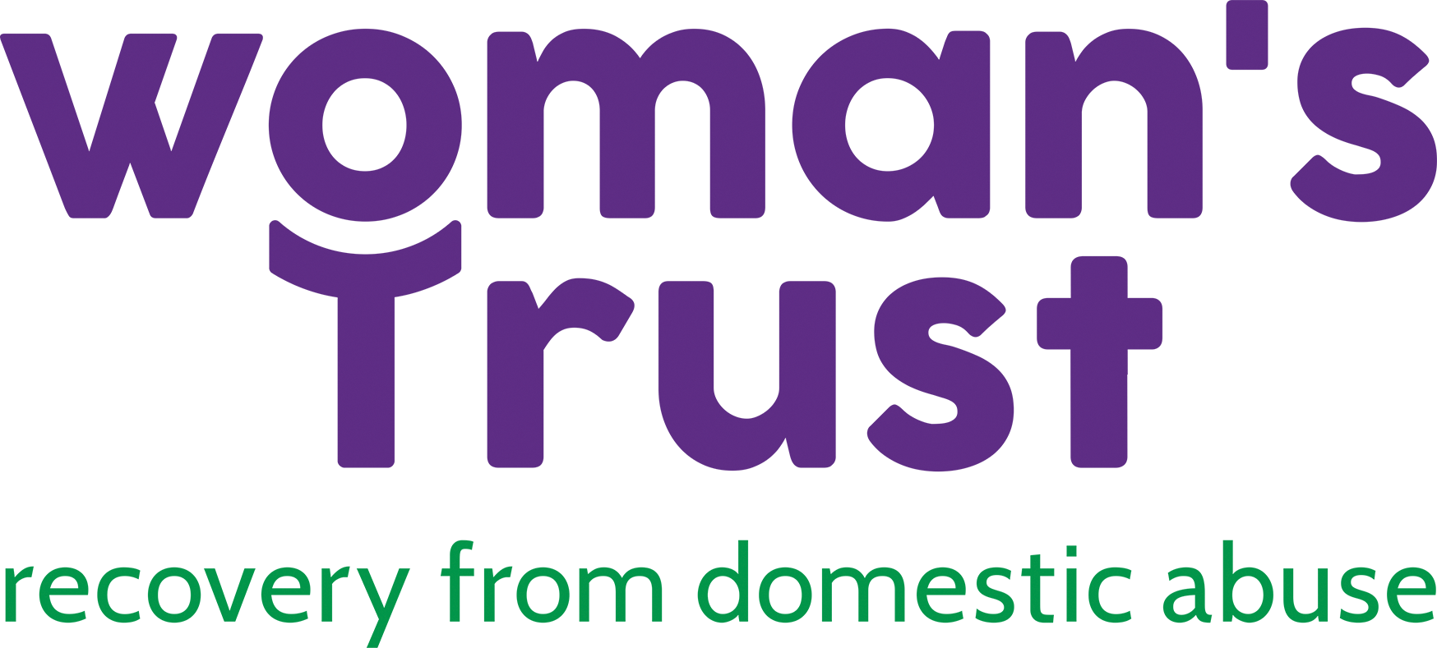
Woman’s Trust Counselling & Support Services

PO Box 70420, London, NW1W 7QL
Phone: 020 7034 0303

Email: recruitment@womanstrust.org.uk

www.womanstrust.org.uk

Dear Applicant,

Thank you for your enquiry about volunteering for Woman’s Trust.

Please find enclosed the following:

✓ Volunteer Counsellor Person Specification
✓ Role Description
✓ Background Information
✓ Equal Opportunities Policy
✓ Application Form
✓ Equal Opportunities Monitoring Form

Please note that CVs are not accepted.

Woman’s Trust is looking for volunteer Counsellors who fulfil the essential criteria set out in the skills and experience requirements. Please address each of the criteria in your application, giving examples of the related work / experience you have. If you are unsure whether you meet the criteria, please contact us and we will be happy to help.

Please note that if you have used any services provided by Woman’s Trust, we ask that five years have passed before you apply for a volunteer Counsellor role with us.

Please email completed application forms to recruitment@womanstrust.org.uk.

We look forward to receiving your application.

Best wishes,

Asiya Mohamed
Clinical Director

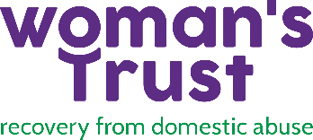
PERSON SPECIFICATION

In completing your application, you will need to address each of these points showing what experience you have in individual areas. Counsellors are shortlisted for interview based on these criteria. You will need to meet all the essential requirements in order to be shortlisted.

You will need to:
- Be at least in the final year of a course in Person-Centred/Humanistic/Integrative counselling or psychotherapy course. If attending an Integrative course, you will need to prove that your main core philosophy is Person-Centred.
- Have a minimum of 50 client hours.
- Be able to work with clients face to face, remotely via telephone and/or a secure platform such as Zoom/Teams
- Ability to work from a Person-Centred/Humanistic approach.
- Be able to manage all administrative tasks, including being confident with IT equipment.
- Be able to manage own caseload including database, notes systems and client communication.
- Have been or are currently in long-term personal therapy.

Knowledge & Skills:
- Demonstrate ability to develop good therapeutic relationships with clients.
- Ability to engage and awareness of the needs of women from a range of cultures, class backgrounds, sexual orientation, disability, and religious beliefs.
- Understanding of emotional and practical issues which might arise in relation to survivors of domestic abuse.
- Understanding of the social, political, and personal impact of domestic abuse
- Understanding of the impact of DV on a woman’s psychological wellbeing

Other:
- Commitment to supporting women who have been affected by domestic abuse.
- Commitment to attending fortnightly supervision as provided by Woman’s Trust
- Commitment to and an understanding of Woman’s Trust Equal Opportunities and Confidentiality Policies
- Ability to work independently, work well under pressure and/or in times of crisis.
- Ability to demonstrate own personal and professional development.

Role Description
- Available to see 4 clients a week in a 4-hour block.

- A commitment to a contract of 18 months is expected in return for training and free supervision by Woman’s Trust

- A six-month probation period will apply. Only after successful completion of this will you be able to record sessions. Specific guidelines will be issued.

- Attendance at the 2 training days is essential as it is part of the interview process. This training can count towards CPD training.

- A commitment to attend fortnightly supervision with a Woman’s Trust supervisor for a minimum of 1.5 hours per month. This might not meet BACP/UKCP/your course requirement. If so, external supervision might be needed as well.

- If any disputes arise between the external supervisor and Woman’s Trust supervisors, the counsellor is required to follow the Woman’s Trust supervisor’s guidelines. Clinical responsibility for the work is held by Woman’s Trust.

- To undertake counselling/therapy work with clients using the Person-Centred/Humanistic approach.

- Commitment to promote safeguarding for young people and vulnerable adults. To be responsible in ensuring that the work follows all Woman’s Trust safeguarding policies and procedures.

- To take responsibility for the management of the work with clients with appropriate supervision and support in the following ways:

- Managing own room booking and client appointments, completing any necessary correspondence and record keeping.

- By honouring the commitment to see clients for the agreed length of time and by regularly attending fortnightly supervision.

- In the case of absence, communicating this to Woman’s Trust and directly to clients, with as much advance notice as is possible. Notice of holidays or other planned breaks should be of at least 4 weeks. Any breaks longer than 2 weeks would need to be pre-arranged with the Line Manager. At times, Woman’s Trust might request that sessions would be ended with clients to facilitate longer absences.

- Termination of Placement: Giving a minimum period of notice of at least 4 weeks to both clients and to Woman’s Trust. Woman’s Trust expect clients will be provided with the full contracted sessions before terminating the placement.

- By always respecting the confidentiality of the client and abiding by Woman’s Trust's confidentiality Policy. All forms and notes belong to Woman’s Trust.

- To return and complete all appropriate paperwork within one week.

- If working face-to-face, to ensure an adequate setting, for example, that a counselling room is booked in advance, that the room is safe and suitable, that the client knows when to arrive and what to do on arrival and where the toilets, fire escapes, etc. are located.

- If working remotely, to ensure that you have access to a confidential space and have appropriate broadband access (for video sessions) and/or telephone connection.

- Reviewing the counselling sessions with the client in session 6 and session 12.

Organisation Background
Woman’s Trust is a registered charity providing a counselling service for women who have been affected by domestic abuse. The service is open to women across London and operates from office in West London (Edgware Road). It has the following aims:

- To provide a high-quality counselling service for women who are affected by domestic abuse.
- To disseminate models of good practice in working with women affected by domestic abuse.
- To undertake outreach work within the community and other relevant organizations to raise public awareness about abuse and violence towards women.

Woman’s Trust is funded by a variety of charitable trusts, some London Boroughs and various grants and fundraises on an ongoing basis for all services.

Applying to Woman’s Trust
Filling in the application is step 1 in Woman’s Trust recruitment procedure. Applicants are shortlisted based on the information that they supply on their application form. You will need to meet all the essential requirements in order to be shortlisted.

If successful at the shortlist stage, you will be invited to attend an interview. If successful at the interview stage, you will be then invited to a two-day training course. The course will be held either in West London (Edgware Road) or remotely. If after the training course you are successful, you will then be offered a placement subject to references and DBS checks.

The placement
Woman’s Trust asks that you commit yourself to this placement for 18 months minimum. During this time, you will see clients for blocks of up to 18 weeks. You will be asked to see 4 clients per week. You will continue your placement and you will allocate your clients accordingly to your time availability.

We strive to fit your placement around your commitments, but restrictions might apply, for example, depending on room availability and the service delivery needs. Your placement will remain the same time each week.

Woman’s Trust offers fortnightly supervision in addition to counsellor’s own college and/or personal supervision. In order to work as a volunteer Counsellor, you are required to attend this supervision. This is to ensure that Woman’s Trust maintains high standards of service to, what can b, a very vulnerable client group in a challenging area. Woman’s Trust is not able to offer placements to volunteer Counsellors who do not attend this supervision. Failure to attend supervision will result in the termination of the placement. The aim of group supervision is mutual support and learning from each other.

Time commitment
The minimum time commitment is 4 hours per week and 6 hours every alternate week (the latter to allow time to attend a supervision group). Travelling time should be factored in addition to these hours.

When considering whether to become a volunteer Counsellor with Woman’s Trust you will need to ensure that you have this time available in your weekly schedule.

EQUAL OPPORTUNTIES POLICY

Statement of intent

Woman’s Trust is actively committed to oppose all forms of discrimination on the grounds of race, culture, sexuality, HIV status, mental health, class, religion, disability, age, marital status, political affiliation, financial and legal immigration status.

Woman’s Trust is committed to taking positive action to combat all direct or indirect discrimination against clients, counsellors, staff, and Management Committee members.

Woman’s Trust is committed to its Equal Opportunities Policy being realised in practice and will continue to amend and update when and where it is necessary and appropriate to do so.

Woman’s Trust aims to be an equal opportunity employer and has a policy for this purpose. Woman’s Trust aims to provide an environment free from harassment and inequality. Woman’s Trust values diversity and believes in providing an environment which promotes fairness, dignity, and respect for everybody within all day-to-day dealings.

The Equal Opportunities Policy will respect all relevant legislation including those detailed below:

The Equality Act 2010 - pursuant to Schedule 9, Part 1 applies.
Rehabilitation of Offenders Act 1974 and 2014
Human Rights Act 1998

A copy of the policy is available from the Woman’s Trust

Application Form

Volunteer Counsellor - Confidential
Registered in England & Wales Company No. 688678, Charity No. 1143513

Please note all placements are for female counsellors only.
The Equality Act 2010 pursuant to Schedule 9, Part 1 applies.

Please state which service area(s) you are applying for: West London ☐ East London ☐
First Name |  |  | Surname

Address

Telephone | Home: Mobile: Work:

Email
How did you hear about this position?
Do you have any special needs or disabilities? – if yes please describe

Please give the name of two referees
Note: One must be your professional clinical supervisor and the other must be your current or most recent employer

- Current/Primary Clinical Supervisor reference 2. Employer reference
Name |  | Name
Address |  | Address
Telephone | Home  Work | Telephone | Home  Work
Email |  | Email
Relationship |  | Relationship

Days Sick Leave in last 12 months

Declaration:
The facts set forth in this application are, to the best of my knowledge, true and complete.

Signature |  | Date

CONFIDENTIAL

Disclosure of Criminal Convictions
Please give brief details of any criminal convictions that you have including any which have been ‘spent’ within the terms of the Rehabilitation of Offenders Act 1974 (Exceptions) Order 1975.
Further details should be sent separately and confidentially to the Therapeutic Services Manager.
Enhanced DBS check will be requested.

Education History (relevant to counselling only)

Dates  From-To | College/University name | Qualifications obtained

Employment or Volunteer Work Experience (relevant to counselling only)

Dates  From-To | Organisation name | Job Title | Main Areas of Responsibility

One- to-one professional counselling hours undertaken.
Dates from – to | Organisation | No of clients | No of hours

LANGUAGES
Other than English, please state any languages you would be comfortable offering counselling in

AVAILABILITY
Please mark the times/days of the week you would be available to see clients and for supervision. Please note it is unlikely that you will be able to see clients and get supervision on the same day.
 | Mon | Tues | Wed | Thurs | Fri
Morning
(9am-1pm)
Afternoon
(1-5pm)
Evening
(From 4pm onwards)

Please indicate which areas of London you are available to see clients.
Westminster | Hammersmith & Fulham | Kensington & Chelsea | Havering
Hackney | Newham | Tower Hamlets | Redbridge
Barking & Dagenham | Waltham Forest
Any other (please state):

Please outline and describe your experiences of personal therapy including how long and the type of therapy that you have received.

Outline your experiences and understanding of trauma/domestic abuse and how you would manage this when working with a very traumatised client group.

What support and plans do you have in place to process the impact of hearing women’s stories and your self-care

Please briefly answer the following questions:
Why do you think women stay in abusive relationships?

What do you think are the main emotional and practical issues for women affected by Domestic abuse?

What therapeutic issues do you think might arise while working with women affected by Domestic Abuse?

What does the person-centred approach mean to you and why is it important in this work?

Please complete this box if you already have/or have had a relationship with a member of staff, supervisor, or student in placement at Woman’s Trust or in training with or at placement in another organisation or if you aware of any possible dual relationship or conflict of interest

Name of person:

Nature of the relationship: (e.g., in same year group or same supervision group or year tutor)

Name of training establishment:

Please return the application form, marking the email CONFIDENTIAL to: recruitment@womanstrust.org.uk

Equal Opportunities Monitoring Form

Date:
Position applied for:

Ethnicity - please mark with an “x”.
Asian
Asian British
Asian Indian
Asian Pakistani
Asian Bangladeshi
Any other Asian background (please specify):

Black
Black British
Black African
Black Caribbean
Any other Asian background (please specify):

Chinese
Southeast Asian (please specify):

Irish Traveller
Romany Gipsy
Other Traveller/Gipsy background (please specify):

Mixed White & Black Caribbean
Mixed White & Black African
Mixed White & Asian
Any other mixed background (please specify):

White British
White Irish
Any other White background (please specify):

I prefer not to answer

Age – please mark with an “x”.
18 – 25
26 – 35
36 - 45
46 - 55
56 - 65
65 +
I prefer not to answer

Gender – please mark with an “x”.
Female
Gender Reassignment (please specify):
I prefer not to answer

Sexual Orientation – please mark with an “x”.
Bisexual
Heterosexual
Lesbian/Gay Woman
Other
I prefer not to answer

Beliefs – please mark with an “x”.
Atheism
Agnosticism
Buddhism
Christianity
Hinduism
Humanism
Islam
Jainism
Judaism
Sikhism
Other (please specify):

None
I prefer not to answer

Do you consider yourself to have a disability? – Please mark with an “x”:
No
Physical Impairment
Sensory Impairment
Learning Disability
Mental Health Condition (long term)
Other Health Condition (long term)
I prefer not to answer

