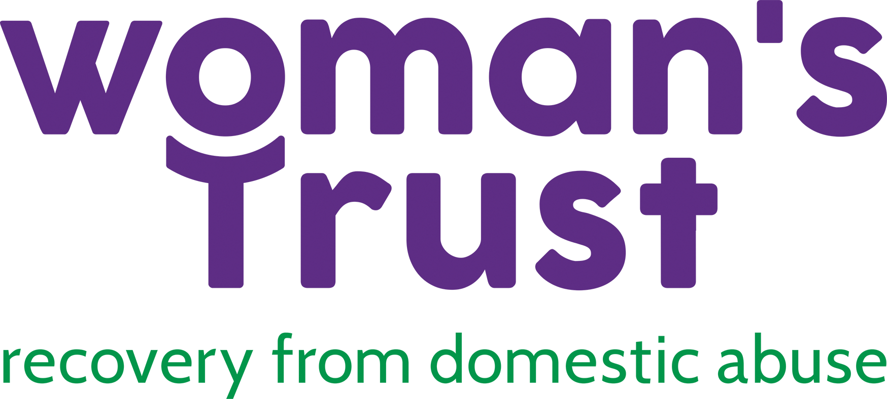

Equal Opportunities form
Date:
Position Applied For:

Ethnicity - please mark with an “x”
Asian
Asian British
Asian Indian
Asian Pakistani
Asian Bangladeshi
Any other Asian background (please specify):

Black
Black British
Black African
Black Caribbean
Any other Black background (please specify):

Chinese
South East Asian (please specify):

Irish Traveller
Romany Gipsy
Other Traveller/Gipsy background (please specify):

Mixed White & Black Caribbean
Mixed White & Black African
Mixed White & Asian
Any other mixed background (please specify):

White British
White Irish
Any other White background (please specify): Scandinavian

I prefer not to answer

Age – please mark with an “x”
18 – 25
26 – 35
36 - 45
46 - 55
56 - 65
65 +
I prefer not to answer

Gender – please mark with an “x”
Female
Gender Reassignment (please specify):
I prefer not to answer

Sexual Orientation – please mark with an “x”
Bisexual
Heterosexual
Lesbian/Gay Woman
Other
I prefer not to answer

Beliefs – please mark with an “x”
Atheism
Agnosticism
Buddhism
Christianity
Hinduism
Humanism
Islam
Jainism
Judaism
Sikhism
Other (please specify): Unspecified Spiritual Belief

None
I prefer not to answer

Do you consider yourself to have a disability? – Please mark with an “x”:
No
Physical Impairment
Sensory Impairment
Learning Disability
Mental Health Condition (long term)
Other Health Condition (long term)
I prefer not to answer

